1st query starting ss:

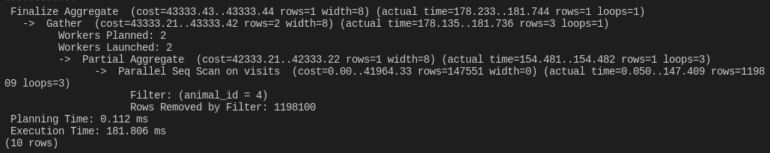1st query fixed ss:

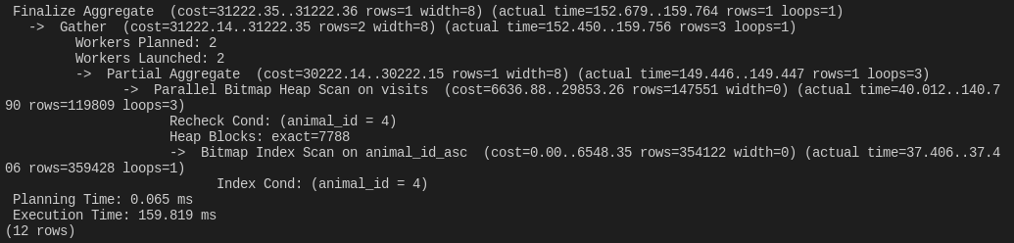

2nd query starting ss:

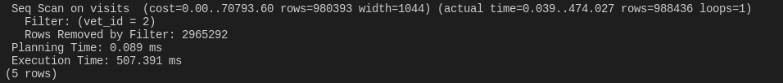

2nd query fixed ss:

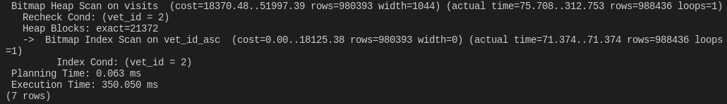

3rd query starting ss:

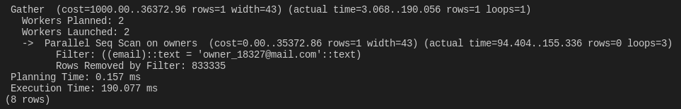

3rd query starting ss:

